AL-HAQQ WEBSITE TEMPLATE

**LOGO:**

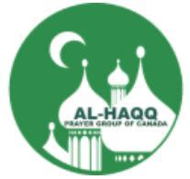

**HOME:**

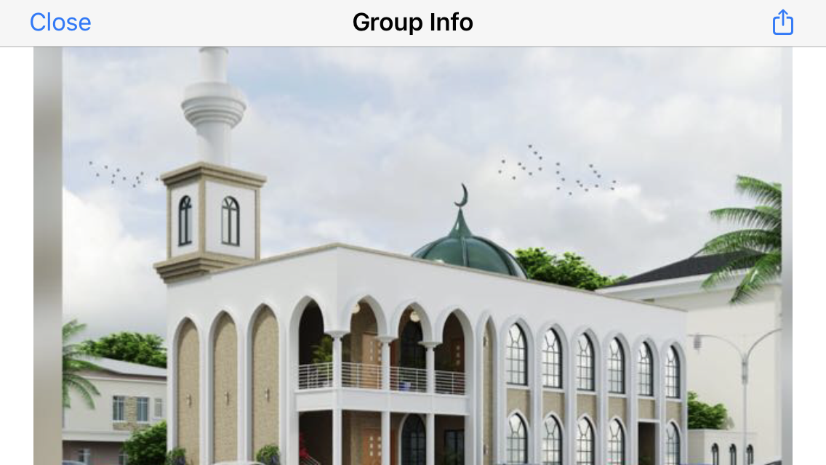



بسم الله الرحمن الرحيم

**DISCOVER ISLAM**

with Al-Haqq Prayer Group of Canada

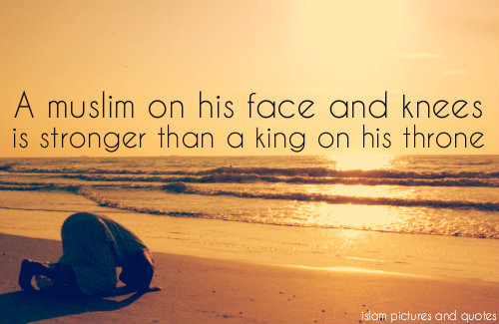



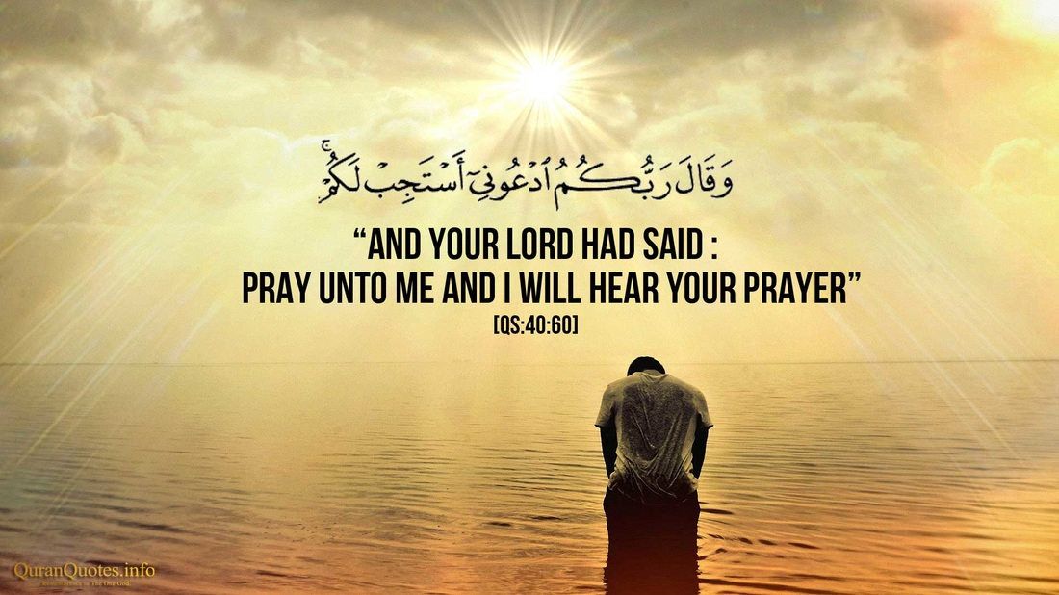

**ABOUT US:**

A**l-Haqq Prayer Group of Canada**is an Islamic prayer group who come together every Sunday to pray and discuss the importance of Islam as a religion and our contributions as a group to our immediate community and beyond. We encourage the young generations to contribute to their immediate communities and aspire to add values in the community.  
We advise and give tips to becoming a better Muslim. We pray and help each other and those in need.

**MISSION AND VISION;**

Striving to be the world leading Islamic Organisation through which learned and spiritual generations evolved “to develop excellent future generations tailored to Islamic paradigm and Beneficial to Mankind.

**AL-HAQQ BOARD OF DIRECTORS**

* ALHAJI KABIR OLADEJI - BOARD CHAIR
* ALHAJA MUTIAT MAKANJUOLA – VICE BOARD CHAIR
* HAMMED AYOADE – SECRETARY
* BROTHER SULAIMAN FAMILUYI – VICE SECRETARY
* ALHAJI BABATUNDE BUSARI – SOCIAL SECRETARY
* MRS HALIMAT SANNI – VICE SOCIAL SECREARY
* BROTHER TAWHID AJOBO – TREASURER
* BROTHER AFEEZ ISMAIL - FINANCIAL SECRETARY
* ALHAJI MONSURU TIJANI – MEMBER AT LARGE
* ALHAJI YUNUS SALAMI – MEMBER AT LARGE

**ACTIVITIES:**

SUNDAYS HALAQA

We regularly come together every Sunday to pray and discuss the importance of Islam as a religion. Our prayer session starts from 9am to 11am in the winter and 9am to 12noon in other seasons. Our Worship Location is at Grand Masjid 2445 Waverly Avenue, Winnipeg. More notes to be added later

SISTERS SESSION; Notes and pictures to be added later

BROTHERS SESSION; Notes and pictures to be added later

EDUCATIONAL PROGRAMS;

* Quran Classes – Online and in-person (Age group; 1-7, 10-12, 13& Above)

Notes and pictures to be added later

**EVENTS:**

**CTV** **Morning live show with Al-Haqq Prayer Group of Canada**  
<http://winnipeg.ctvnews.ca/mobile/video?clipId=1154626>

[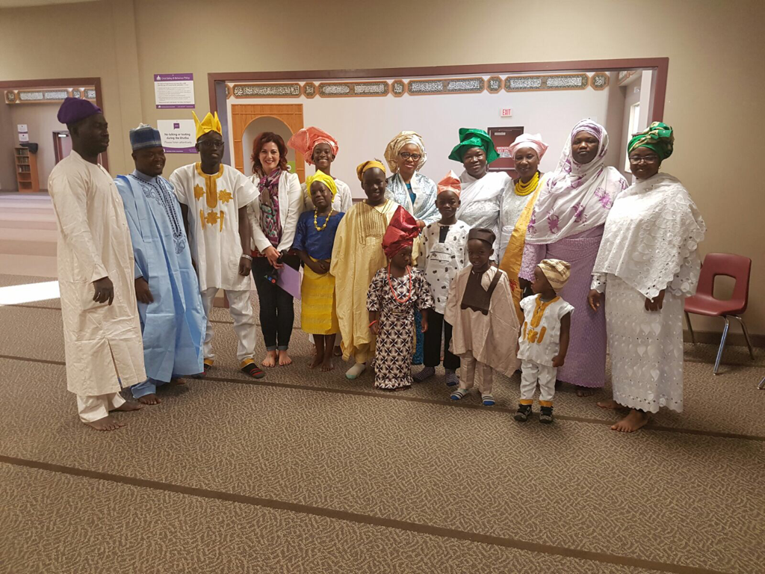](https://www.alhaqqcanada.ca/uploads/8/0/8/8/80882330/p91_orig.png)

**Al-Haqq Prayer Group donated Zakat Contributions to Winnipeg Harvest in Winnipeg to cater for the people in need**

|  |
| --- |
|  |

|  |
| --- |
|  |

OTHER EVENTS PICTURES CAN BE MOVED FROM OUR PREVIOUS WEBSITE: www.alhaqqcanada.ca

|  |  |
| --- | --- |
|  | |
| **CONTACT US**  Contact us to ask any questions about upcoming events or concerns. We would be happy to answer your questions and comments.  Top of Form  * Indicates required field  Name *  First  Last  Email *    Comment *      **Submit**  Bottom of Form | **EMAIL ADDRESS**  [alhaqqcanada@yahoo.com](mailto:alhaqqcanada@yahoo.com)  **TELEPHONE NUMBER:**  (204)- 799-0389, (204) 510-2308  **PHYSICAL ADDRESS:**  2445 Waverly St, Winnipeg, MB R3Y 1S3  Canada.  **MAILING ADDRESS:**  55 Southbridge Drive  Winnipeg, MB R2J 4A4  Canada |

**DONATIONS:**

Donate Now to:

General Organization Operations;

Donation Amount:

$20

$50

$100

Others

To Islamic Resource Centre/Masjid Project:

Donation Amount:

$20

$50

$100

Others



Donation Frequency

One-time

Monthly

Dedication

I am an

Individual

Organization

First Name

Last Name

Email

Phone

Address











MESSAGE FOR AL-HAQQ PRAYER GROUP OF CANADA. (OPTIONAL)

**CAREERS:**

NO JOB POSTINGS FOR NOW.

**LECTURES:**

DATE: Oct 24th 2021

TOPIC: PARENTING IN THE WESTERN WORLD

TIME: 10:00AM (CANADA), 4:00PM (NIGERIA)

QUEST SPEAKER: SISTER SHAHINA SIDDIQUI (ED DIRECTOR – ISLAMIC SOCIAL SERVICES ASSOCIATION, CANADA)

DATE: NOV 7TH, 2021

TOPIC: WHY DIVOICE? / ISLAMIC PERSPECTIVE ON DIVOICE

TIME: 10:30AM (CANADA), 4:30PM (NIGERIA)

QUEST SPEAKER: DR ABUDLLATEEF ABUDLHAKEEM (CHIEF IMAM LAGOS STATE HOUSE OF ASSEMBLY MOSQUE, LAGOS)